CHAPTER 1
INTRODUCTION

1.1 BACKGROUND AND MOTIVATION
In recent years, the number of road accidents caused by driver fatigue and drowsiness has seen a significant increase. According to global traffic safety reports, considerable percentage of fatal vehicle collisions occur due to human error particularly when the driver falls asleep while driving. This poses a grave threat not only to the driver but also to passengers, pedestrians, and other road users. Long-distance truck drivers, night-shift workers, and individuals driving for extended periods are especially vulnerable to this issue.

The need to ensure safety on roads has inspired the development of various advanced driver assistance systems (ADAS). One such concept gaining importance is drowsiness detection and alert systems. While previous models have focused on simple warning mechanisms such as buzzers, there is a growing necessity for smarter, more proactive solutions that not only alert the driver but also actively prevent accidents. Our project is motivated by this need—to go beyond the alarm system and implement a mechanism that stops the vehicle when the driver is detected to be asleep.

1.2 IMPORTANCE OF DRIVER DROWSINESS DETECTION
Driver drowsiness detection systems are crucial in preventing road accidents by monitoring the alertness level of the driver. Drowsiness while driving reduces a person’s attention, delays reaction time, and impairs decision-making ability, leading to serious accidents. Recognizing the signs of fatigue and responding in real time can save countless lives.

Traditional systems merely sound an alarm when sleep is detected, which may not always be enough to awaken the driver or prevent an accident. Integrating safety mechanisms such as automatic engine cutoff can provide an added layer of protection. Thus, driver drowsiness detection is no longer just a feature of luxury vehicles but a necessary safety component that should be accessible in all types of transportation
1.3 OVERVIEW OF ANTI-SLEEP TECHNOLOGY
Anti-sleep technology encompasses a range of sensors and algorithms designed to monitor driver behavior, detect fatigue indicators, and respond effectively. Techniques such as eye blink detection using infrared sensors or camera-based systems have shown promising results in identifying drowsy behavior.

In our project, we utilize an Eye Blink Sensor to monitor the driver's eyes in real time. When a prolonged eye closure (indicating sleep) is detected, the system immediately activates a buzzer alarm and simultaneously triggers a relay circuit to stop the motor, mimicking a vehicle stopping mechanism. This approach not only alerts the driver but also brings the vehicle to a halt to avoid possible crashes.
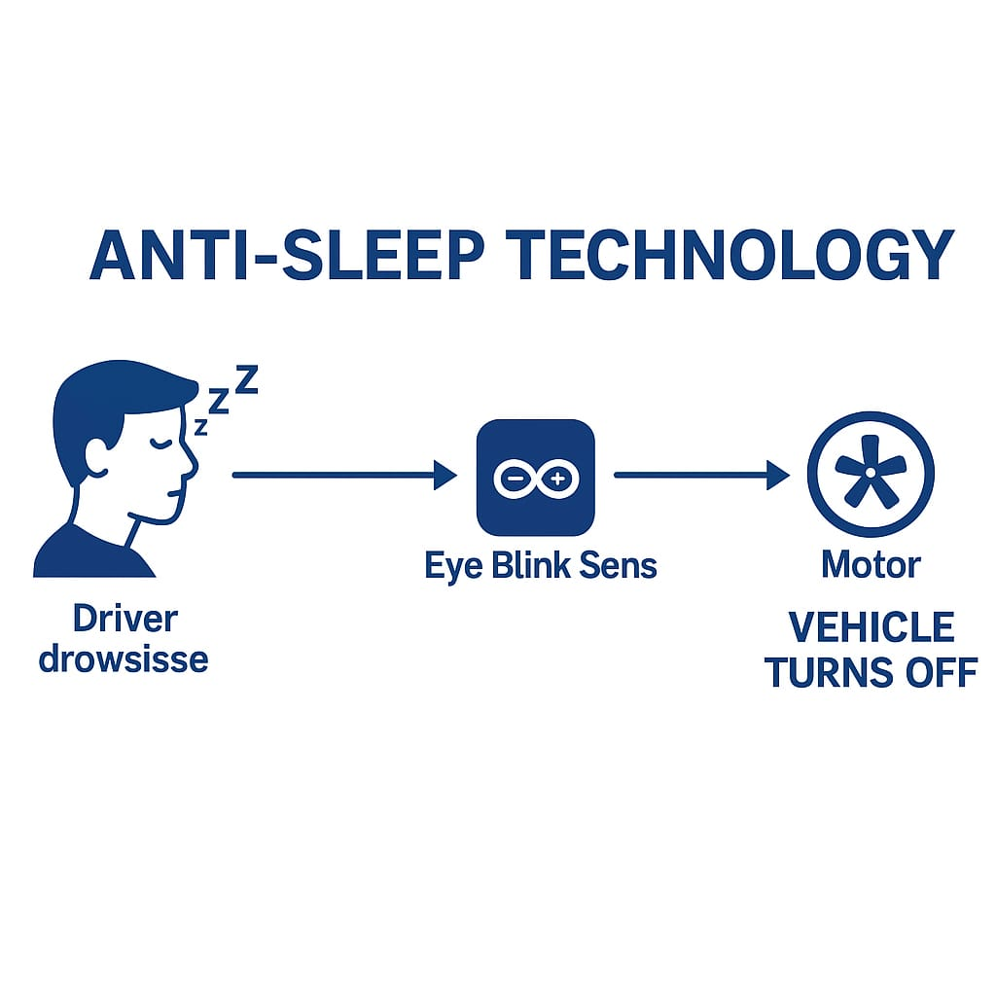
FIG 1.3: OVERVIEW OF ANTI-SLEEP TECHNOLOGY

1.4 PROBLEM STATEMENT
Despite the availability of alarm-based systems, the rate of accidents due to drowsy drivers remains high. Existing technologies fall short in terms of ensuring the driver's safety after an alarm is triggered. A simple buzzer might fail to wake up the driver or may not prevent an accident if the vehicle continues moving.Hence, there is a need for a more effective system that not only detects drowsiness but also takes preventive action in this case, stopping the motor to minimize the risk of accidents. The current project seeks to address this limitation by developing a practical, affordable, and real-time solution using easily available electronic components.
1.5 OBJECTIVES OF THE PROJECT
To develop a driver monitoring system using an eye blink sensor.
To trigger an alert (buzzer) when drowsiness is detected.
To automatically stop the motor (vehicle) to prevent potential accidents.
To create a low-cost and reliable safety system suitable for all types of vehicles.
To increase awareness about road safety through practical technological solutions.

1.6 SCOPE AND SIGNIFICANCE
This project focuses on improving vehicular safety by integrating automation into driver fatigue detection systems. It is designed to function in low-budget environments, making it accessible for personal vehicles, college-level projects, and public transportation safety applications.

The scope includes the design, development, and testing of a prototype system using Arduino Uno, an eye blink sensor, relay modules, a motor, and a buzzer. The system is tested in controlled environments and can be adapted for use in real-time vehicle applications with further enhancements.

The significance of this project lies in its preventive capability—offering not just a warning but an active intervention, which can prove to be a lifesaver in critical moments.

1.7 RELEVANCE TO ROAD SAFETY AND PUBLIC HEALTH
Road safety is a global public health concern, and initiatives that contribute to reducing accidents directly impact the well-being of communities. By focusing on accident prevention through early detection of fatigue and automatic intervention, this project serves as a model for future safety technologies.

Implementing such systems can contribute to fewer road accidents, reduced hospitalizations, and minimized loss of life and property. Therefore, the Anti-Sleep Detector Alarm is not only an engineering solution but also a step toward promoting public health and safety.
CHAPTER 2
RELATED WORK

2.1 REVIEW OF EXISTING DRIVER FATIGUE DETECTION TECHNOLOGIES
Driver fatigue detection technologies have evolved significantly in recent years, aiming to reduce road accidents caused by drowsy driving. Several systems have been proposed and implemented, focusing mainly on real-time monitoring of the driver's physical and behavioral patterns. These include eye blink detection, steering pattern monitoring, and physiological sensors to analyze fatigue levels.

2.2 TRADITIONAL ALERT SYSTEMS (BUZZER-BASED)
Many early driver fatigue detection systems employed a buzzer alert system. These systems rely on a basic input—typically from an eye blink sensor—that detects when the driver’s eyes are closed for an abnormal period. Once this condition is met, a buzzer is triggered to wake the driver. Though simple and cost-effective, these systems have limitations in ensuring continued safety, as they do not take any proactive control measures over the vehicle.

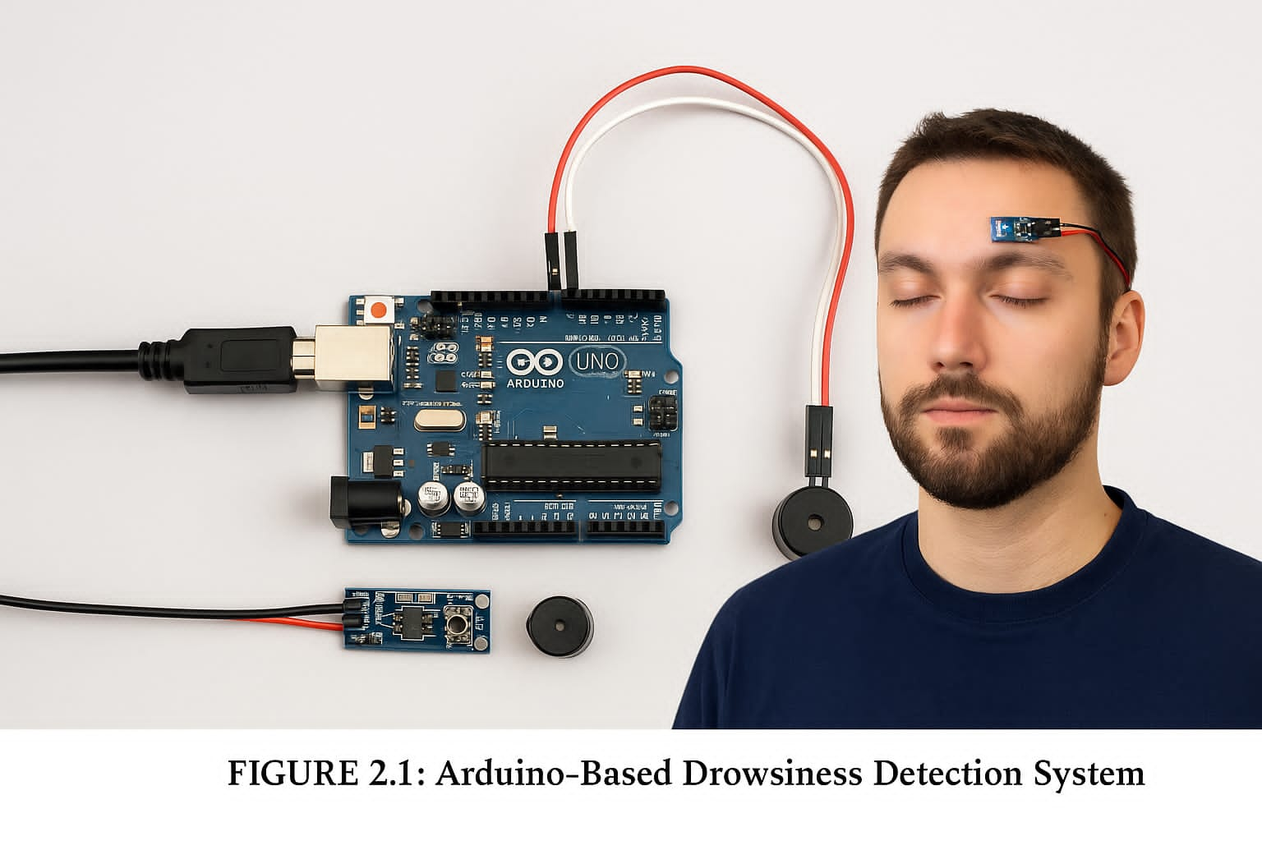FIG 2.1: ARDUINO-BASED DROWSINESS DETECTION SYSTEM

2.3 SENSOR-BASED EYE BLINK DETECTION
Eye blink detection systems are among the most popular fatigue detection methods. These systems use infrared or camera-based sensors to detect the frequency and duration of eye closure. If the driver's eyes remain closed beyond a threshold, an alarm is triggered. This technique is effective but depends heavily on ambient lighting and sensor accuracy.

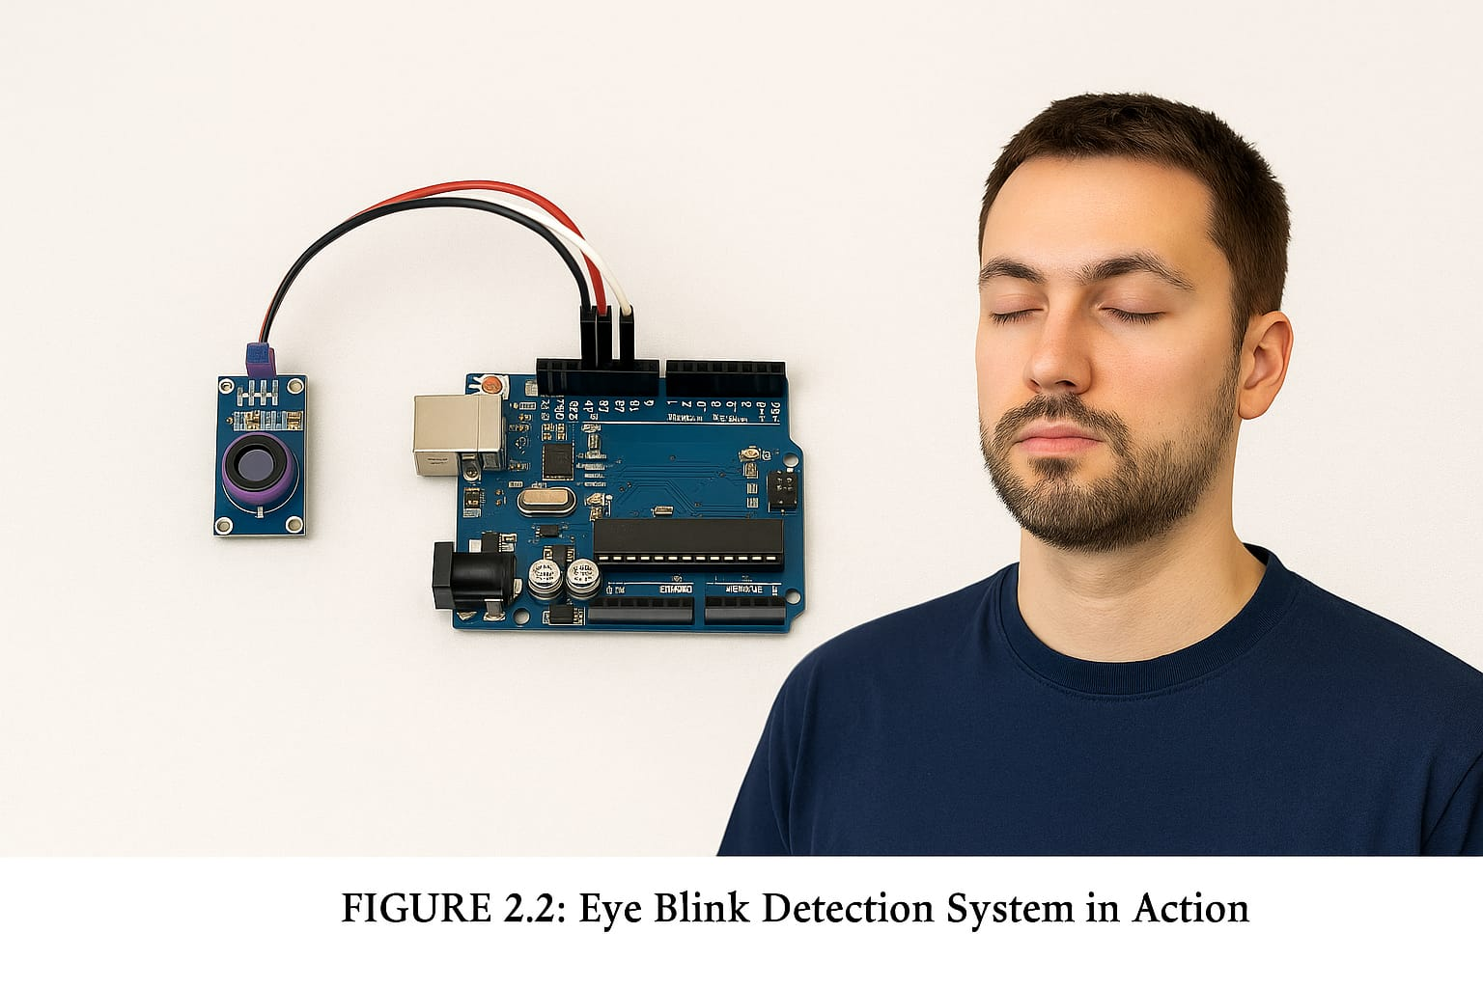FIG 2.2: EYE BLINK DETECTION SYSTEM IN ACTION CAPTION: EYE BLINK DETECTION

2.4 MACHINE LEARNING AND CAMERA-BASED DETECTION APPROACHES
Recent advancements have led to the integration of machine learning algorithms with camera-based facial recognition systems. These systems detect facial expressions, yawning, head tilts, and eye movements. They require substantial processing power and are generally expensive, making them unsuitable for low-budget implementations like student or small-scale projects.

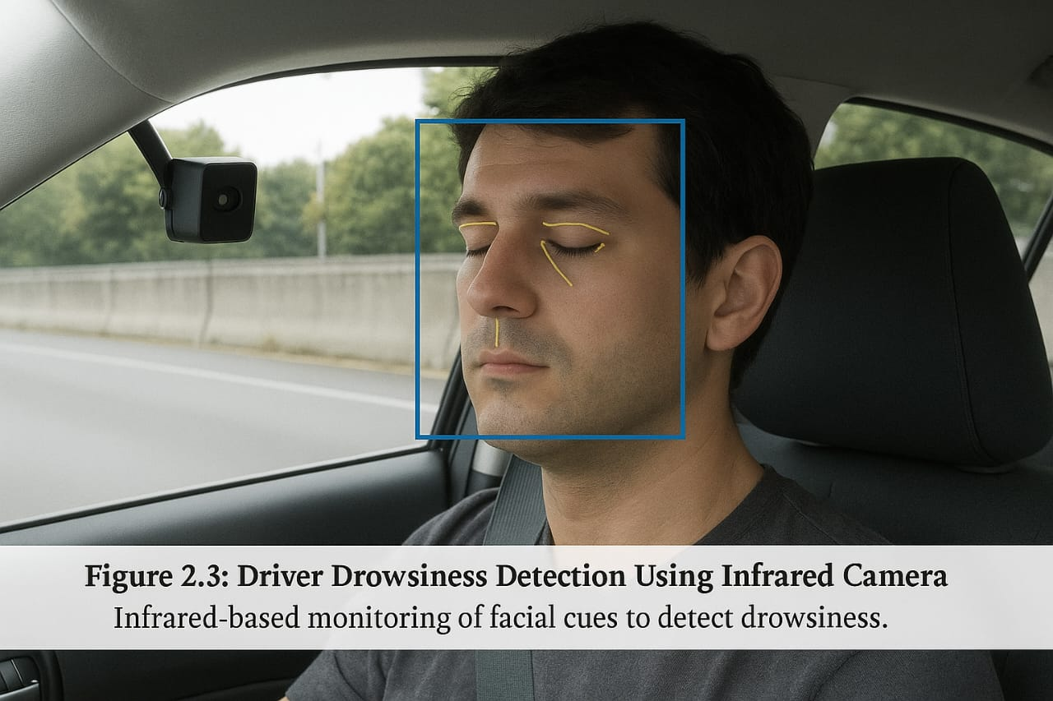
FIG 2.3: DRIVER DROWSINESS DETECTION USING INFRARED CAMERA

2.5 COMPARISON AND ANALYSIS OF PRIOR SYSTEMS
While traditional buzzer-based systems provide a reactive approach, they fail to ensure complete safety in critical situations. Camera and machine learning-based systems provide better accuracy but come at a higher cost. Most systems lack integration with control mechanisms to prevent potential accidents. This gap lays the foundation for enhanced systems that combine both alerting and preventive actions.

2.6 GAPS AND LIMITATIONS IN CURRENT TECHNOLOGIES
Existing technologies are generally limited to alerting the driver but do not take preventive action such as stopping the vehicle. This presents a significant gap, especially in scenarios where the driver does not respond to alarms. Therefore, there is a need for an enhanced system that not only alerts but also initiates safety measures like disabling the vehicle movement.

SUMMARY: The reviewed systems show that while there are various technologies to detect driver drowsiness, most are either alert-only or high-cost solutions. The need for a comprehensive yet low-cost system that includes both alerting and active intervention is evident, which is addressed in the proposed system discussed in Chapter 3.
CHAPTER 3
PROPOSED WORK

3.1 INTRODUCTION TO PROPOSED SYSTEM
Drowsiness while driving is a major cause of road accidents globally. The proposed system aims to address this challenge by continuously monitoring the driver’s eye activity using an Eye Blink Sensor. When the driver’s eyes remain closed for a certain duration (indicating sleep or extreme drowsiness), the system activates a buzzer to alert the driver and deactivates the motor to halt the vehicle if necessary. This smart safety system is built on an Arduino microcontroller platform, providing an affordable, real-time, and effective solution to driver fatigue.

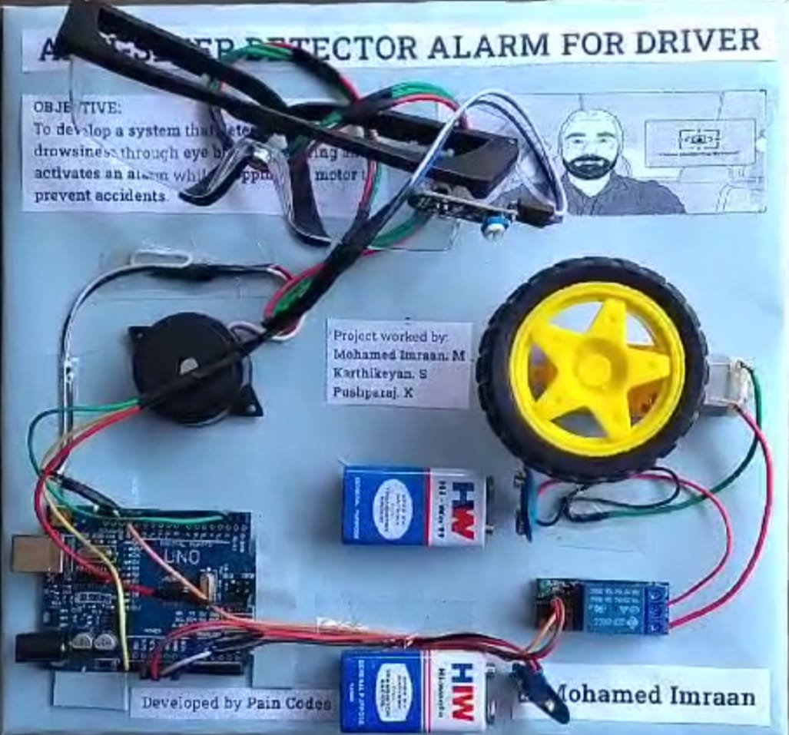

FIG 3.1: ANTI-SLEEP DETECTOR ALARM FOR DRIVER

3.2 SYSTEM ARCHITECTURE AND DESIGN
The system architecture is a combination of hardware and software integration. It consists of a sensor layer for detection, a control layer for decision-making, and an output layer for actions. Here is a layered breakdown:
- Input Layer: Eye Blink Sensor
- Processing Layer: Arduino UNO (micro-controller)
- Output Layer: Buzzer and Motor (via Relay)
- Power Source: 9V battery or USB supply

KEY FEATURES:
- Real-time detection
- Low-cost and easy-to-deploy
- Can be integrated into existing vehicles
- Expandable with IoT/GPS modules in future versions

3.3 HARDWARE AND COMPONENTS USED
The components used are readily available and inexpensive, which makes the project suitable for prototyping or educational purposes.
S.No | Component | Quantity | Description
1 | Arduino UNO | 1 | Controls the entire logic
2 | Eye Blink Sensor | 1 | Detects eye closure duration
3 | Buzzer | 1 | Produces an alarm sound to alert the driver
4 | Gear Motor | 1 | Simulates vehicle movement
5 | Relay Module (5V) | 1 | Acts as a switch for the motor
6 | 9V Battery + Connector | 1 | Powers the system
7 | Jumper Wires | As needed | For circuit connections
8 | Breadboard | 1 | Used for prototyping the circuit

3.4 SOFTWARE AND PROGRAMMING FLOW
The code is written in Arduino IDE using C/C++-like syntax. The Eye Blink Sensor is connected to a digital pin and continuously monitored. The logic includes:
- Initialize all components
- Monitor Eye Blink sensor output
- If eyes are closed for a defined threshold (e.g., 3–5 seconds):
- Trigger buzzer
- Turn off motor using relay
- Else, keep the motor ON and no buzzer
- Software Tools Used:
- Arduino IDE
- Serial Monitor (for debugging)

3.5 WORKING PRINCIPLE AND FUNCTIONAL FLOW
The Eye Blink Sensor emits IR rays and detects reflection from the eyeball. When the eyes close, the reflection is reduced, and the sensor sends a LOW signal to Arduino.

FUNCTIONAL FLOW:
1. Eye Blink Sensor checks eye status
2. If eyes closed > 3 seconds → send alert
3. Arduino activates buzzer + relay
4. Motor stops
5. System resets once eyes are opened again

This ensures the driver gets alerted and the system takes necessary action to avoid accidents.

3.6 BLOCK DIAGRAM AND CIRCUIT EXPLANATION
BLOCKDiagram: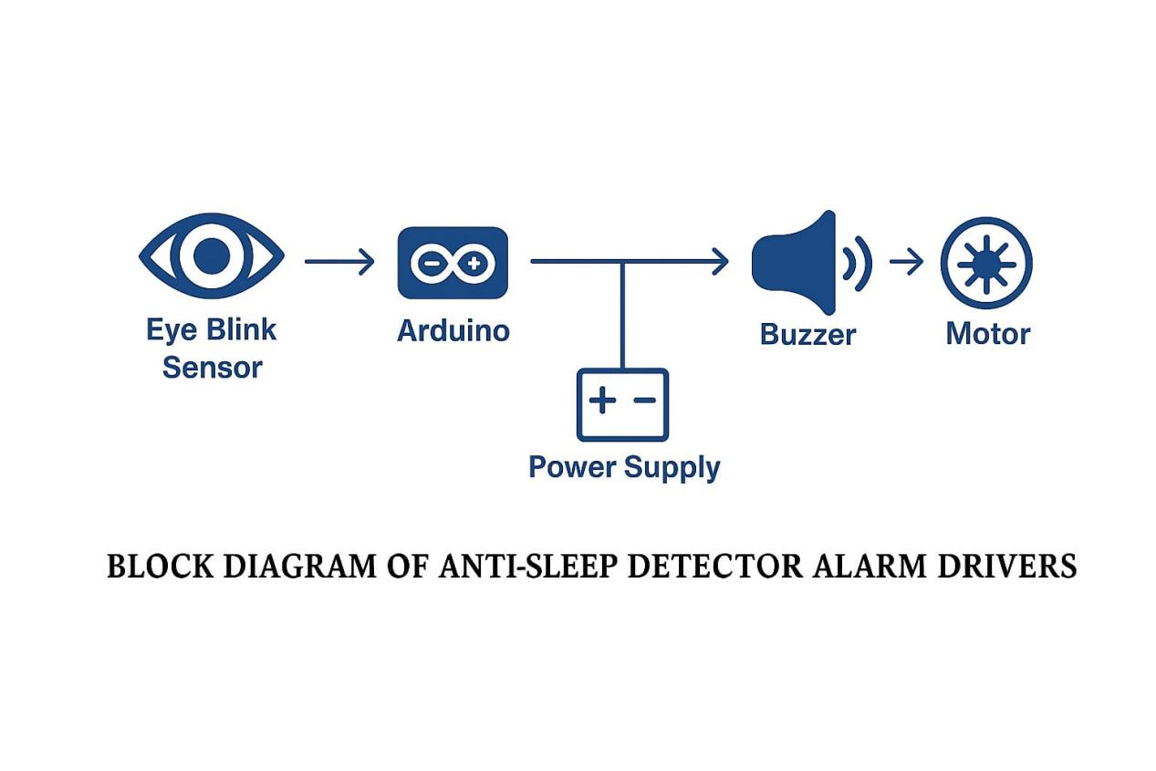
FIG 3.2: Block diagram of Anti sleep detector alarm for driver
EXPLANATION:
The Eye Blink Sensor feeds real-time data to Arduino UNO.
Power supply energizes all components.
On detecting drowsiness, Arduino triggers the buzzer and deactivates the motor using a relay module.

CIRCUIT DIAGRAM:

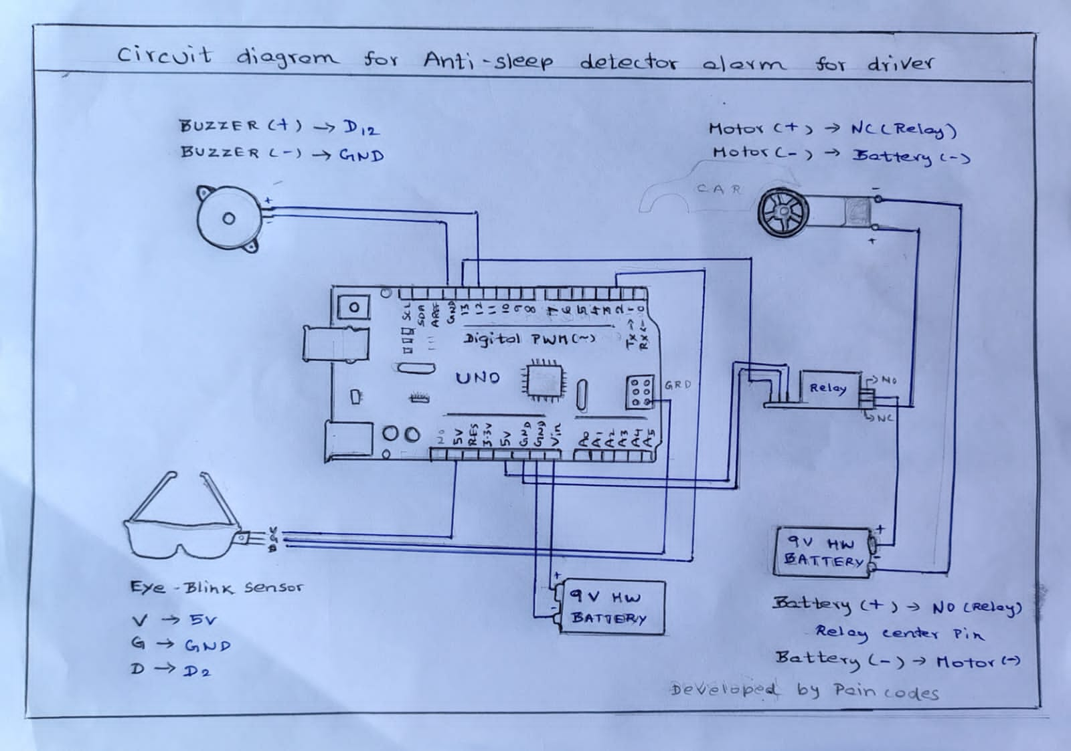

FIG 3.6: CIRCUIT DIAGRAM FOR ANTI SLEEP DETECTOR ALARM

3.7 PROGRAM CODE:
//Program code for Anti sleep alarm Detector for drivers
//Mohamed Imraan [ Pain codes ]

const int blinkPin = 2;
const int motorPin = 13;
const int buzzerPin = 12;

long time;

void setup() {
pinMode(motorPin, OUTPUT);
pinMode(buzzerPin, OUTPUT);
pinMode(blinkPin, INPUT);
digitalWrite(motorPin, HIGH);
}

void loop() {

if(!digitalRead(blinkPin)){
time=millis();
while(!digitalRead(blinkPin)){
digitalWrite(buzzerPin, LOW);
digitalWrite(motorPin, LOW);
delay(1000);
}
}
else {
if(TimeDelay()>=3)digitalWrite(buzzerPin, HIGH);
if(TimeDelay()>=4)digitalWrite(motorPin, HIGH);
}
}

int TimeDelay(){
long t=millis()-time;
t=t/1000;
return t;

3.8 ADVANTAGES OVER EXISTING METHODS

Cost Low : Uses basic and affordable components.

Real-Time: Monitors the driver continuously.

Simple Design: Easy to build and replicate.

Immediate Response: Activates alerts within seconds.

Extendable: Can be connected to IoT for advanced features.

3.9 REAL-TIME APPLICATION AND IMPACT
This system can be installed in:
- Public transport vehicles (buses, trucks)
- Private vehicles for long-distance drivers
- School and college buses

Impact:
- Helps in reducing road accidents due to driver fatigue
- Enhances vehicle safety systems
- Provides a foundation for smart vehicle automation

CHAPTER 4
OUTPUT AND RESULT

4.1 SYSTEM TESTING ENVIRONMENT
In this section, describe the setup and conditions under which the system was tested. This could include:
- Hardware used (Arduino Uno, eye blink sensor, relay module, motor, etc.)
- Software setup (Arduino IDE, code used for detection and response)
- Testing location/environment (lab setup, vehicle environment, etc.)
- External factors affecting performance (light conditions, sensor accuracy, etc.)

4.2 DEMONSTRATION OF EYE-BLINK DETECTION
Provide an explanation of how the eye-blink detection works in the system. Include:
- The process of detecting the driver's eye movement or blink using the sensor
- The threshold values set for blink detection
- A demonstration of the system triggering an alarm when no blink is detected for a set duration (indicating sleep or drowsiness)
- Test results showing how the system detects blinking and its effectiveness in various lighting conditions.

4.3 MOTOR CUT-OFF AND BUZZER RESPONSE
Explain how the system reacts when sleep is detected:
- The immediate response of cutting off the motor (using the relay module) when no eye-blink is detected
- The activation of the buzzer as an alert mechanism for the driver
- Demonstrate the response time and how quickly the system reacts to a lack of blinking
- Include any time delays, if present, for safety or reliability purposes.

4.4 OUTPUT SNAPSHOTS AND DESCRIPTIONS
Provide visual outputs or screenshots of the system in action:
- Photos or videos showing the system running on the Arduino Uno setup
- Close-ups of the eye-blink sensor detecting and triggering events
- Visuals of the motor cut-off and buzzer activation during testing
- Descriptions explaining what each snapshot represents and how it relates to the system's functionality.

4.5 ANALYSIS OF RESULTS AND OBSERVATIONS
Analyze the data and performance results from your testing:
- Discuss how effective the eye-blink detection was in various test scenarios
- Evaluate the response time and reliability of the motor cut-off and buzzer activation
- Present any data or graphs showing the system's performance under different conditions
- Highlight any areas where the system performed well or where improvements are needed.

4.6 CHALLENGES DURING IMPLEMENTATION
Identify and describe any difficulties faced during the development and testing phases:
- Technical issues with hardware components (e.g., motor, sensor inaccuracies, relay module failure)
- Software-related challenges in configuring the blink detection algorithm
- Environmental challenges affecting sensor accuracy (lighting, driver behavior)
- Other challenges like power consumption, integration with the motor, or system stability
Solutions or workarounds implemented to address these challenges

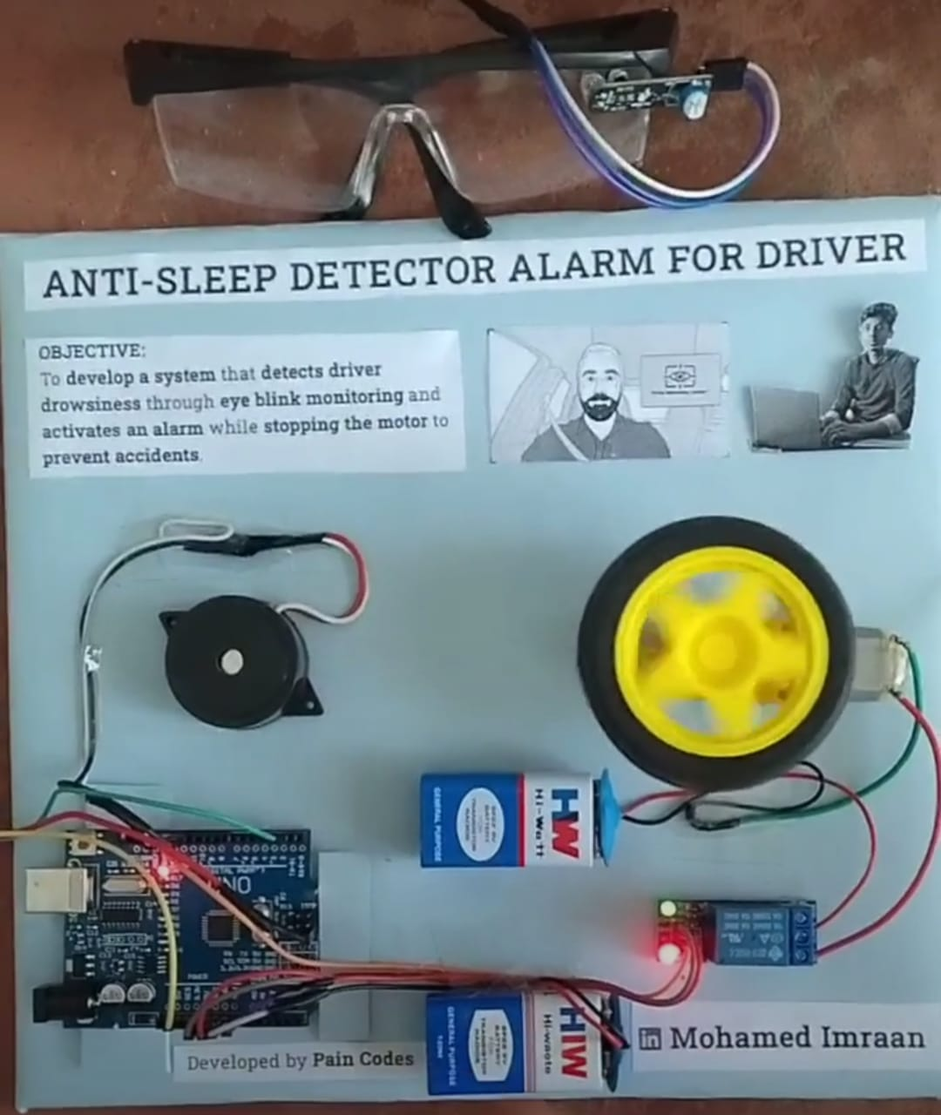

FIG 4.1: OUTPUT DURING ON STATE

The output of the Anti-Sleep Detector Alarm system is demonstrated through a setup involving an Arduino Uno, eye blink sensor, relay module, and a gear motor. When the system detects signs of driver drowsiness—such as prolonged eye closure—the sensor sends a signal to the Arduino. This triggers the buzzer alarm and simultaneously stops the motor through the relay module, simulating the halting of a vehicle to prevent accidents. The setup visually represents the real-time response of the system during the active (drowsy detected) state.
CHAPTER 5
CONCLUSION

5.1 SUMMARY OF WORK
This project aimed to design and implement an "Anti-Sleep Detector Alarm for Drivers" using an eye-blink sensor, Arduino Uno, buzzer, relay module, and gear motor. The system was developed to enhance driver safety by detecting signs of drowsiness and responding with immediate alerts. The core functionality included real-time monitoring of the driver’s eye activity, activating a buzzer, and cutting off the motor (simulating vehicle stoppage) when drowsiness is detected. The hardware setup was successfully integrated and tested under controlled conditions to demonstrate its effectiveness.

5.2 EFFECTIVENESS OF THE ANTI-SLEEP ALARM SYSTEM
The system proved effective in detecting prolonged eye closure, a common sign of driver sleepiness. Upon detection, the buzzer alerted the driver and the relay triggered the motor shutdown promptly. This immediate response mimics a safety mechanism that can prevent potential accidents. The system was responsive and reliable under normal lighting conditions, achieving its primary objective of sleep detection and prevention.

5.3 PROJECT LEARNING AND EXPERIENCE
Throughout the project, valuable hands-on experience was gained in multiple domains:
- Embedded systems – Integrating sensors, microcontrollers, and actuators
- Hardware troubleshooting – Handling power issues, signal interference, and component alignment
- Programming – Writing and debugging real-time logic in the Arduino environment
- Teamwork and planning – Managing tasks, deadlines, and testing protocols
- This project also improved problem-solving skills and deepened understanding of real-world safety applications of electronics.

5.4 LIMITATIONS AND CONSTRAINTS
Despite successful implementation, the system has some limitations:
- The eye-blink sensor may give false positives in poor lighting or due to glasses or obstructions
- The system was tested in a lab, not in a real moving vehicle, which may affect real-world accuracy
- The current setup supports only basic sleep detection and does not differentiate between natural blinks and prolonged closure
- Power supply and portability constraints may affect integration into actual vehicles

5.5 FUTURE ENHANCEMENTS AND SCOPE
Several improvements can be made to increase the reliability and practical application of the system:
- Integrating a camera-based AI system to enhance detection accuracy through facial recognition and eye-tracking
- Adding IoT and cloud connectivity to log data for analysis and alert external systems
- Implementing driver behavior analysis for more comprehensive drowsiness detection
- Designing a compact and automotive-compatible PCB version of the system
- Using machine learning algorithms to adapt to individual driver patterns and reduce false alarms
- With further development, this project can evolve into a robust safety feature for commercial and personal vehicles.

APPLICATIONS:
- Enhances driver safety in long-distance and commercial vehicles (trucks, buses)
- Useful in personal cars as an affordable anti-fatigue alert system.
- Applicable in industries where operators handle critical machinery
- Ideal for academic projects related to embedded systems and road safety.

